**NAME : SOMAGUTTA PAVAN KUMAR REDDY**

**COLLEGE : Dhanalakshmi Srinivasan University,trichy, Tamil Nadu**

**MAIL : somaguttapavankumarreddy@gmail.com**

**ENERGY CONSUMPTION TREND ANALYSIS**

**Problem Statements:-**

1. Analyze trends in energy consumption (water, electricity, and gas) across different buildings, cities, or years.
2. Develop a Power BI dashboard to analyze and compare energy consumption and costs across various departments or business units, helping identify energy-intensive areas.
3. Build an interactive dashboard to analyze hourly, daily, and monthly peak energy usage, enabling businesses to optimize operations during peak demand hours.
4. Develop a Power BI dashboard to compare energy costs, consumption, and trends across different energy types, helping businesses prioritize cost-effective sources.
5. Design a Power BI dashboard to show the contribution of renewable energy sources, highlighting total savings, environmental impact, and energy usage trends.
6. Develop a dashboard to identify anomalies in energy consumption patterns using historical trends, helping businesses address unusual usage promptly.
7. Create a Power BI dashboard to compare energy costs and consumption trends across locations, helping identify underperforming or inefficient sites.

8.Calculate the total cost of energy consumption by combining the consumption data with rate information.

9.Focuses on optimizing future operations by analyzing historical data and rate impacts.

**SCREENSHOT:- imported data into power bi**

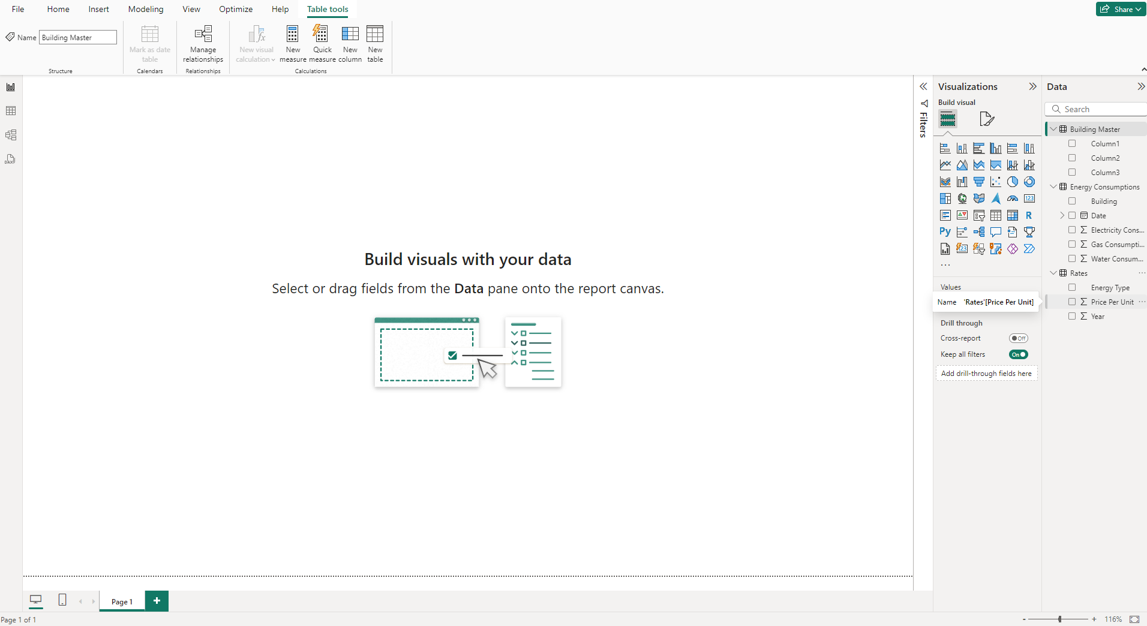

**CONCLUSION**

The data provides valuable insights into energy consumption patterns and costs across multiple buildings and cities.

1. Water consumption is the most significant contributor to overall energy usage, with buildings like B1006 leading in high consumption.
2. Gas consumption is relatively lower but shows variability across buildings, with B1004 in Chicago standing out.
3. The steady rise in energy prices (2016–2020), particularly for gas, highlights the growing cost burden for high-consumption buildings.
4. Location-specific patterns reveal that cities like New York have the highest overall consumption, while Chicago and Los Angeles show moderate to variable usage.

To manage costs effectively, focusing on high-consumption buildings and optimizing energy use is critical. This analysis can guide energy-saving strategies and cost forecasting.